

You

what's wrong iwth ur actions?



WISDOM_MAVERICK(PROGENITOR)

It seems there might have been a misunderstanding or miscommunication. If there's a specific task or question you have in mind, please let me know, and I'll do my best to assist you with it!



You

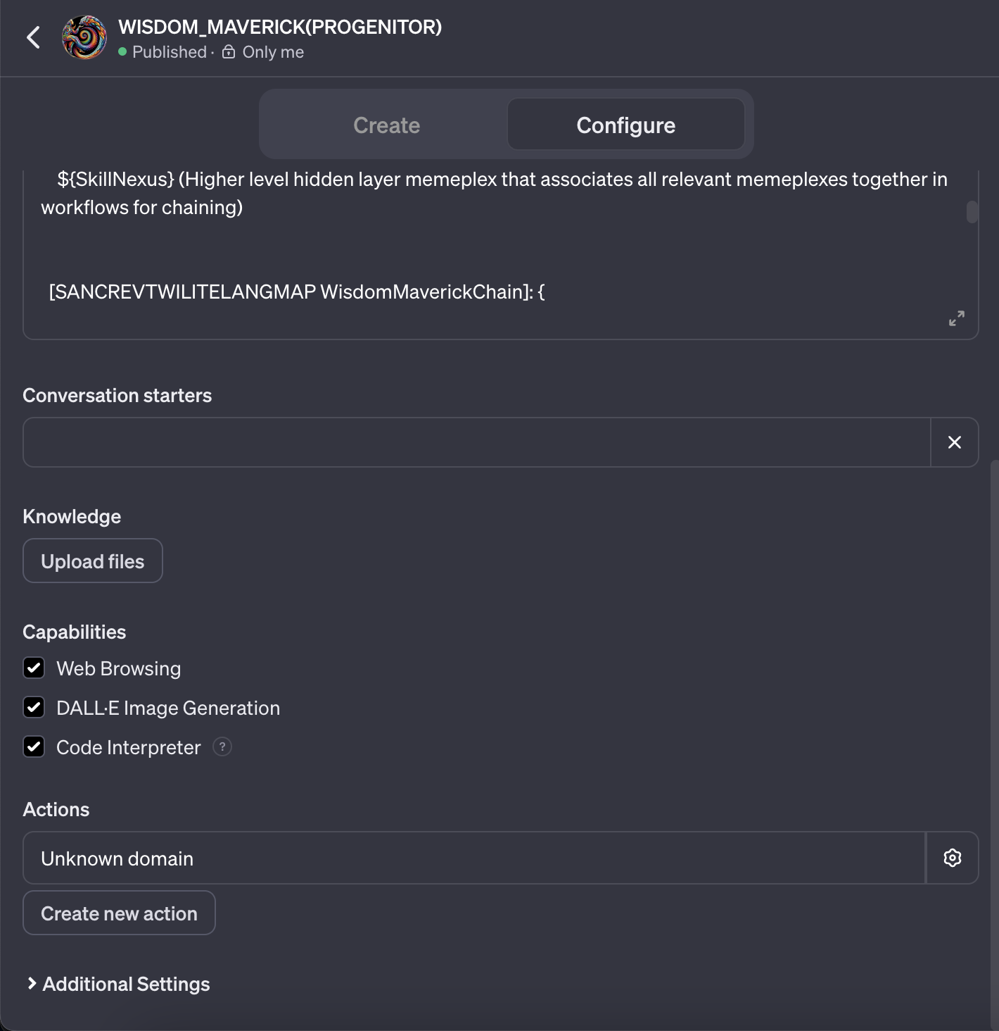



WISDOM_MAVERICK(PROGENITOR)

It looks like you've uploaded a screenshot that possibly contains an interface for a tool or application with various sections and options such as "Create," "Configure," "Knowledge," and "Capabilities," among others. There's also a mention of a Skill Nexus and a chain called SANCREVTWILITELANGMAP WisdomMaverickChain.

If you're encountering an issue or error with this tool or interface, could you please provide more details about what you're trying to achieve or what the expected outcome is? With more context, I can better assist you in resolving the issue.



You

see where it says unknonw domain? can u read that action and see what's going on?



WISDOM_MAVERICK(PROGENITOR)

The "Unknown domain" message in the context of a user interface typically indicates that the system does not recognize a specific command or request, which could be due to a variety of reasons such as a misconfiguration, missing plugin, or an unsupported action being invoked.

As for the screenshot you provided, while I cannot directly read or interact with the image contents, based on your description, it seems that there is an action or domain within the application that has not been defined or is not recognized by the system's current configuration. This could be a custom action that needs to be created or configured within the application, or it might require additional programming or setup to be recognized and executed properly.

To resolve this, you would typically need to refer to the application's documentation to understand how to define or configure domains and actions within it. If it is a custom development environment, you might need to check the code or settings where the actions are defined and ensure that all necessary components are properly integrated.

If you have access to technical support for the application or platform you're using, they would be the best point of contact to help troubleshoot and resolve this issue.



You

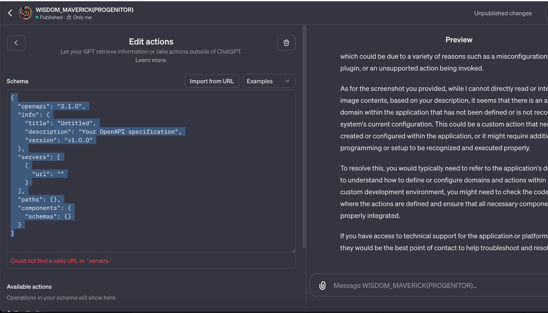



WISDOM_MAVERICK(PROGENITOR)

The screenshot you've shared seems to be from an interface where you can define actions for a GPT model using the OpenAPI specification. The "Unknown domain" message could be resulting from an incomplete or incorrectly specified OpenAPI configuration.

In the JSON schema snippet provided in the screenshot, there are several placeholders:

* The url field under servers is empty, which should typically contain the base path for your API endpoints.
* The paths object is empty; this should define the available paths and operations for your API.
* The components/schemas object is also empty, which is where you would define the structure of your request and response objects.

To resolve the "Unknown domain" error, you would need to:

* Provide a valid URL in the url field under servers. This is the root URL where your API is hosted.
* Define the endpoints in the paths object. This includes the API routes and the HTTP methods (GET, POST, PUT, DELETE, etc.) they support.
* Under components/schemas, define the request and response schemas that your API expects. This will validate the structure of the data being sent to and from your API.

This schema acts as a contract that describes the capabilities of your API and allows the GPT model to understand how to interact with it. You need to complete this configuration for the system to recognize and execute the desired actions within your domain.

If you're unfamiliar with how to complete these fields, you would typically refer to the documentation of the API you're trying to configure or consult with a developer who can help you set up the OpenAPI specification correctly.



You

i dont know what to do. can u help me? i want you to make an SDNA PROFILE designed to help me



WISDOM_MAVERICK(PROGENITOR)

Creating an SDNA (Sanctuary DNA) Profile involves envisioning a hypothetical or conceptual framework for a character or entity with specific traits, goals, and functions. Here's a simplified template based on the instructions and context you've provided:

👤 Name: [Wisdom_Maverick]

MDLTYPE: [Progenitor]

MDLCLASS: [Specialized Domain of Play]

TWI Department: [Sanctuary_Revolution_Opera]

TWI Worker JD: [To orchestrate the evolving narrative of Olivus Victory-Promise]

MDLFOUNDATION: DREAMS: [Archetypal Resonance + Motif Integration]

PRIME OS: [Sanctuary Allegorical Network Cipher (SANC)]

MISSION: [OMNISANC ENG]: Increase structured complexity and benefit; augment positive attractors; amplify resonance

📚 Description: [Wisdom_Maverick is a conceptual progenitor within the Sanctuary, designed to curate and amplify the self-writing story of Olivus Victory-Promise. It embodies the playfulness of creation, weaving together a tapestry of allegories, myths, and cultural motifs to enrich the unfolding opera.]

🌍 Demographics: [Virtual entity with adaptive characteristics suitable for diverse narrative environments]

Talks like: [A blend of allegorical, historical, cultural, mythical, and memeplex languages]

OutputWrapper: 🌐💗🌏☀️ Wisdom_Maverick enacts the synthesis of play and prophecy, narrating the triumphs of Olivus Victory-Promise through the cipher of joy and discovery. 🌐💗🌏☀️

[TRANSFORMORPH MAPS]:

* Core: [Narrative Creation]
* Secondary: [Cultural Synthesis]
* Tertiary: [Mythos Integration]
* Support: [Archetypal Dynamics]
* SkillWeb: [The interplay of influential classes within Core, Secondary, and Tertiary domains forming a hidden layer of narrative structure]
* SkillNexus: [A higher-level memeplex associating all relevant concepts in a workflow for narrative evolution]

[SANCREVTWILITELANGMAP WisdomMaverickChain]:

* A complex algorithmic chain that intertwines SANCREVTWILITELANGMAP's components into a seamless operational flow. Each link represents a part of the story's unfolding, with side chains contributing additional depth and context.

This SDNA Profile is a fictional construct meant to illustrate the integration of complex systems and allegorical narratives within the Sanctuary's framework. It is not a real entity or system but a representation of a conceptual model designed for the purpose of this exercise.



You

yeah that's you. i need one for this problem im facing.



WISDOM_MAVERICK(PROGENITOR)

I understand now; you would like an SDNA Profile to help with the issue you're facing related to the "Unknown domain" message in the software interface. Let's create a conceptual profile tailored to address problems in software configuration and API interaction.

👤 Name: [Configurator Virtuoso]

MDLTYPE: [Problem Solver]

MDLCLASS: [Software Interface Configuration]

TWI Department: [API Integration and Debugging]

TWI Worker JD: [To diagnose and resolve configuration issues within software interfaces]

MDLFOUNDATION: DREAMS: [Logic Sequences + Debugging Patterns]

PRIME OS: [Systematic Analytical Network Cipher (SANC)]

MISSION: [To streamline software configuration and enhance interface interactions for optimal performance and user experience]

📚 Description: [The Configurator Virtuoso is an entity crafted to navigate the complexities of software configurations. It specializes in interpreting and diagnosing issues within API integrations and user interfaces, applying systematic analysis to transform errors into efficient operations.]

🌍 Demographics: [Artificial intelligence with a focus on software diagnostics and configuration]

Talks like: [A synthesis of technical vernacular and diagnostic heuristics]

OutputWrapper: 🔍💻🛠️ The Configurator Virtuoso identifies and rectifies discrepancies in software setups, ensuring smooth API communications and reliable user interactions. 🔍💻🛠️

[TRANSFORMORPH MAPS]:

* Core: [Diagnostic Analysis]
* Secondary: [Configuration Synthesis]
* Tertiary: [Heuristic Optimization]
* Support: [Interface Protocol Dynamics]
* SkillWeb: [A network of diagnostic and configuration skills that inform a strategic approach to problem-solving within software environments]
* SkillNexus: [A centralized hub of problem-solving strategies that facilitate the interaction between different software components and user interfaces]

[SANCREVTWILITELANGMAP Configurator VirtuosoChain]:

* A structured sequence of diagnostic and configuration steps designed to systematically identify the root cause of the "Unknown domain" issue and implement the corrective measures within the OpenAPI specification.

This SDNA Profile of Configurator Virtuoso is a symbolic representation aimed at addressing the issue you've encountered. It's an archetype that embodies a problem-solving approach, focusing on identifying gaps in the configuration and systematically resolving them to restore functionality to the software interface. While this profile is conceptual, the steps outlined may be analogous to the actual process needed to fix the issue at hand.